1.

List the members of the set
P = {factors of 30 which are odd}.
A.
P = {2, 3, 5}
B.
P = {1, 2, 3, 5}
C.
P = {1, 3, 5, 15}
D.
P = {2, 6, 10, 30}

2.

M = {g, o, q, s} and W = {h, p, r, t}. Find W U W.
A.
{q, r, s, t}
B.
{g, h, o, q, r}
C.
{g, h, o, q, r, t}
D.
{g, h, o, p, q, r, s, t}

3.

Name the geometrical figure shown in the diagram below.
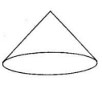
A.
Cuboid
B.
Cone
C.
Pyramid
D.
Sphere

4.

Express
5
16
as a decimal fraction.
A.
0.3333
B.
0.3125
C.
0.2667
D.
0.2500

5.

If y = -
1
2
x + 6, find y when x = 4.
A.
-2
B
B.
2
C.
4
D.
8

6.

The marks obtained by 13 candidates in a test are 5, 7, 2, 9, 11, 10, 2, 12, 2, 9, 3, 18 and 2.
Use this information to answer the question below.
What is the mode?
A.
2
B.
5
C.
9
D.
18

7.

The marks obtained by 13 candidates in a test are 5, 7, 2, 9, 11, 10, 2, 12, 2, 9, 3, 18 and 2.
Use this information to answer the question below.
Find the median.
A.
9
B.
7
C.
5
D.
2

8.

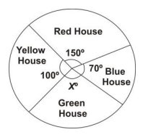
The pie chart above shows the distribution of 360 pupils to various houses in a school.
Use it to answer the question below
Find the value of the angle marked X°.
A.
30°
B.
40°
C.
100°
D.
150°

9.

The pie chart above shows the distribution of 360 pupils to various houses in a school.
Use it to answer the question below
How many more students are in Yellow House than in Blue House?
A.
30
B.
40
C.
70
D.
100

10.

Express 242 as a product of prime factors.
A.
2² x 11²
B.
2 x 11²
C.
2² x 11
D.
2 x 11

11.

Change 110011_{two} to number in base ten.
A.
51
B.
50
C.
48
D.
32

12.

A boy throws a die once. What is the probability of getting the number 4?
A.
1
6
B.
1
3
C.
1
2
D.
5
6

13.

Arrange the following fractions from the highest to the lowest:
5
6
,
4
5
and
4
7
A.
4
7
,
4
5
,
5
6
B.
4
5
,
5
6
,
4
7
C.
5
6
,
4
5
,
4
7
D.
4
7
,
5
6
,
4
5

14.

Solve the inequality 3x + 6 ≤ 5x - 2.
A.
x ≤ 2
B.
x ≥ 2
C.
x ≤ 4
D.
x ≥ 4

15.

If 8x - 3(2x - 4) = 4, find the value of x.
A.
-8
B.
-4
C.
4
D.
8

16.

Use the diagram below to answer the question below.
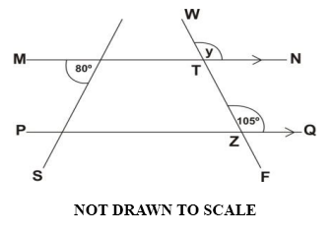
Find the size of angle y.
A.
75°
B.
80°
C.
100°
D.
105°

17.

Use the diagram below to answer the question below.
Angles NTZ and QZT are
A.
alternate angles.
B.
corresponding angles
C.
complementary angles
D.
supplementary angles

18.

Factorize
1
4
px² +
1
8
px.
A.
1
4
px(x + 2)
B.
1
4
px(x +
1
2
)
C.
1
8
px(
1
2
x + 2)
D.
1
8
px(x + 2)

19.

Jojo and Fiifi shared an amount of money in the ratio 3 : 4 respectively. If Fiifi had ₵ 140, 000 how much was shared?
A.
₵ 200,000.00
B.
₵ 220,000.00
C.
₵ 245,000.00
D.
₵ 280,000.00

20.

Simplify 6(7a + 4) - 3(8a + 9)
A.
18a - 3
B.
18a + 51
C.
42a - 27
D.
66a -3

21.

A man invested ₵ 500,000.00 at 15% simple interest per annum for 2 years. Calculate the amount at the end of the period.
A.
₵ 350,000.00
B.
₵ 650,000.00
C.
₵ 750,000.00
D.
₵ 800,000.00

22.

Make m the subject of p =
3m + 1
m
.
A.
m = 3p + 1
B.
m = p - 3
C.
m =
1
p - 3
D.
m =
3p + 1
p

23.

Simplify 200 x 0.01 x 372 leaving your answer in standard form.
A.
74.4 x 10¹
B.
7.44 x 10¹
C.
7.44 x 10²
D.
7.44 x 10⁴

24.

What percentage of 5 is 0.25?
A.
4%
B.
5%
C.
20%
D.
25%

25.

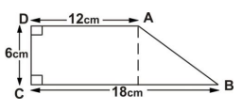
Calculate the area of the figure ABCD above.
A.
72 cm²
B.
90 cm²
C.
108 cm²
D.
126 cm²

26.

In which of the following constructions is P equidistant from the points A and B?
A.
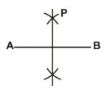
B.
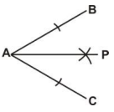
C.
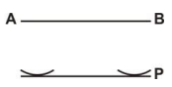
D.
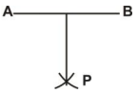

27.

If a : 27 = 6 : 18, find a.
A.
4
B.
9
C.
51
D.
81

28.

The diagram below shows a circle center O. If A and B are points on the circle, what name is given to the shaded region?
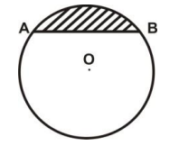
A.
Chord
B.
Segment
C.
Sector
D.
Arc

29.

An amount of ₵ 5, 400.00 is shared among three sisters in the ratio of their ages. Their ages are 10 years, 6 years and 2 years. Find the share of the youngest sister.
A.
₵ 300.00
B.
₵ 600.00
C.
₵ 1,200.00
D.
₵ 1,800.00

30.

Find the Least Common Multiple(L.C.M) of 4, 5 and 6.
A.
20
B.
24
C.
30
D.
60

31.

Expand (a + 2b)(a - 2b)
A.
a² - 4ab - 4b²
B.
a² + 4ab - 4b²
C.
a² - 4b²
D.
a² + 4b²

32.

If a woman was paid ₵180,000.00 for working for 4
1
2
days, how much would she be paid for one day?
A.
₵40,000.00
B.
₵45,000.00
C.
₵54,000.00
D.
₵81,000.00

33.

Express 0.68 as a fraction in its lowest term.
A.
7
25
B.
17
25
C.
3
5
D.
7
15

34.

Write down all the integers within the interval 21 < y ≤ 27.
A.
{21, 22, 23, 24, 25, 26, 27}
B.
{22, 23, 24, 25, 26, 27}
C.
{21, 22, 23, 24, 25, 26}
D.
{22, 23, 24, 25, 26}

35.

Simplify (2⁶ x 3⁴) ÷ (2⁴ x 3²)
A.
2² x 3²
B.
2² x 3⁶
C.
2¹⁰ x 3²
D.
2¹⁰ x 3⁶

36.

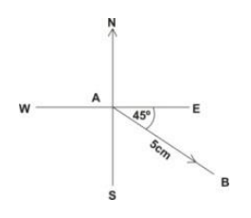
Which of the following is represented by vector AB
→
in the diagram above?
A.
(5 cm, 045°)
B.
(5 cm, 135°)
C.
(5 cm, 180°)
D.
(5 cm, 225°)

37.

Solve for y, if 3 + 3y = 1 - 13y
A.
-
1
8
B.
-
1
4
C.
1
8
D.
1
4

38.

Convert 37_{ten} to a base two numeral.
A.
100101
B.
100111
C.
101101
D.
110101

39.

The length of a rectangular playing field is 5 metres longer than its width. If the perimeter of the field is 150 metres, find its width.
A.
30 metres
B.
35 metres
C.
40 metres
D.
45 metres

40.

If the vector m =
(
3
2
)
and n =
(
-1
3
)
, find m - 2n.
A.
(
-1
4
)
B.
(
1
-4
)
C.
(
5
4
)
D.
(
5
-4
)

